To: Thang Duong

Quotation
No. USA052303
Issue Date: | 05/23/03
Valid Until: | 07/23/03
Email: thangd@uclink.berkeley.edu

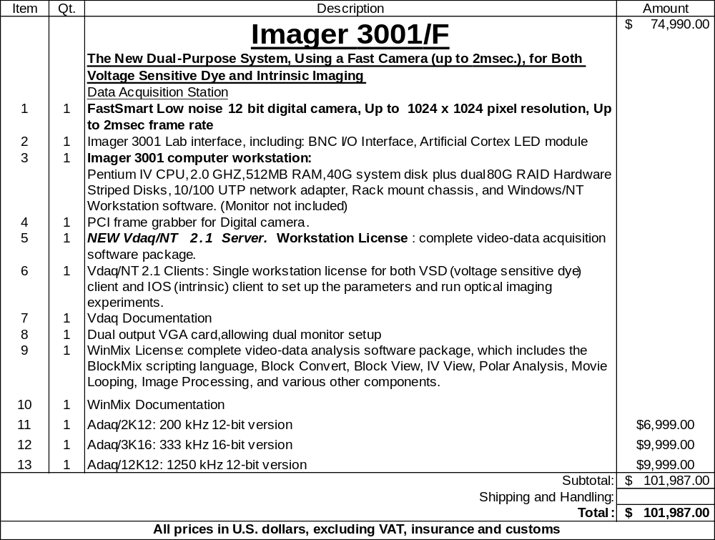

Terms: 25% upon placing order, 75% remainder, NET two weeks after delivery
Shipment: Air freight and handling: Prepaid by OI- will be added to invoice.
The cost is buyer’s sole responsibility
Warranty: One year from date of shipment/Three years on OI lab interface.
Subject to the return of the Warranty form by the User

Estimated shipping date: 2-3 month from receipt of purchase order.

Approved by

____________________________
Mrs. Gwen Hanlon Howard

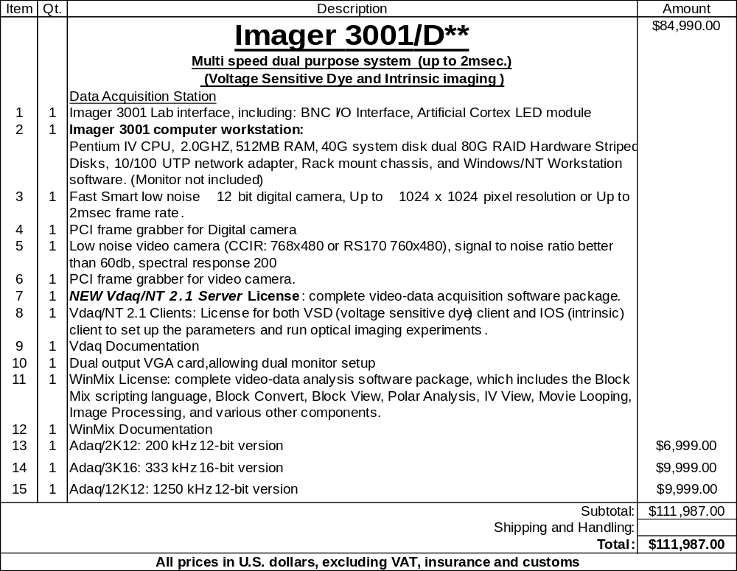
** This dual system, including both video and FastSmart cameras, combines the best of both worlds: The Fast Smart camera offers the superior image frame rate. The video system requires much less storage space--facilitating longer experiments, more extensive signal averaging, more stimulus conditions, faster data analysis, faster backup time, etc.

Terms: 25% upon placing order, 75% remainder, NET two weeks after delivery
Shipment: Air freight and handling: Prepaid by OI- will be added to invoice.
The cost is buyer’s sole responsibility
Warranty: One year from date of shipment/Three years on OI lab interface.
Subject to the return of the Warranty form by the User

Estimated shipping date: 2-3 month from receipt of purchase order.

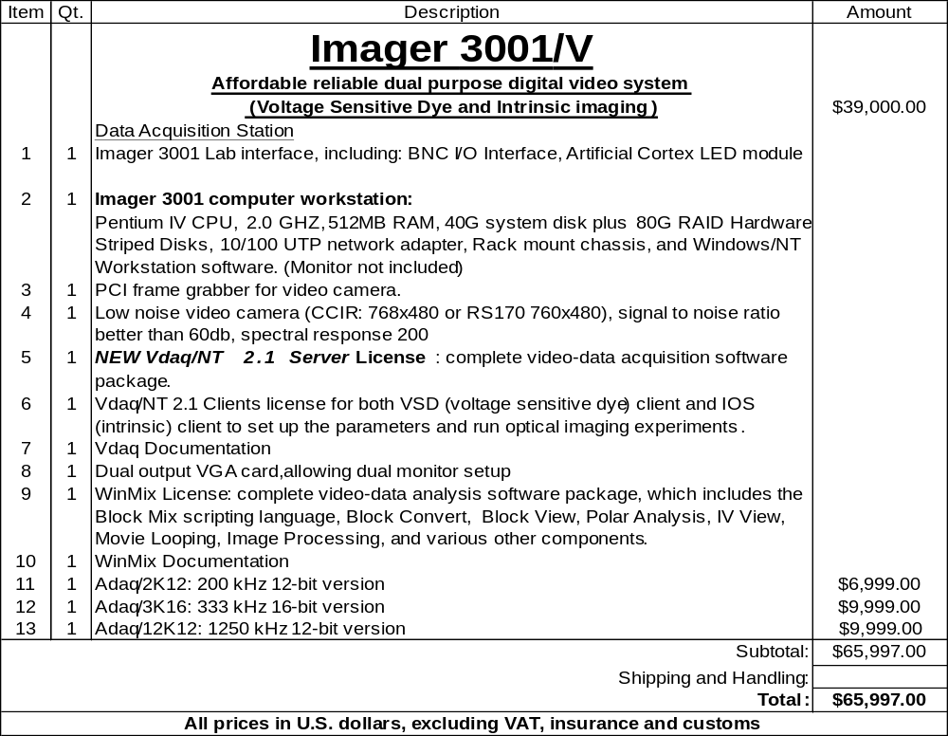
Terms: 25% upon placing order, 75% remainder, NET two weeks after delivery
Shipment: Air freight and handling: Prepaid by OI- will be added to invoice.
The cost is buyer’s sole responsibility
Warranty: One year from date of shipment/Three years on OI lab interface.
Subject to the return of the Warranty form by the User

Estimated shipping date: 2-3 month from receipt of purchase order.

Computer Options

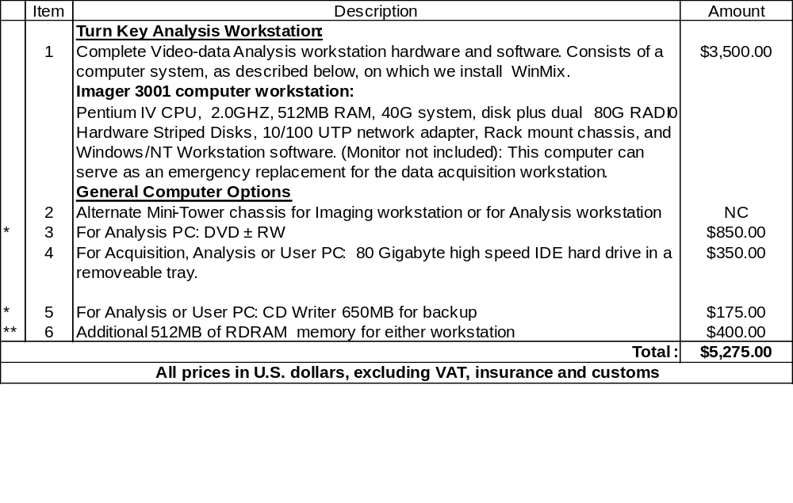

* This option is only to be installed on an analysis computer.

** Highly recommended for acquisition workstation

Note, due to space limitations, you can only have one of the following options on an Analysis or Acquisition PC: DVD-RAM, CD Writer, or 80G IDE Tray in a single computer.

Accessories

10% discount for all orders filed with the main system

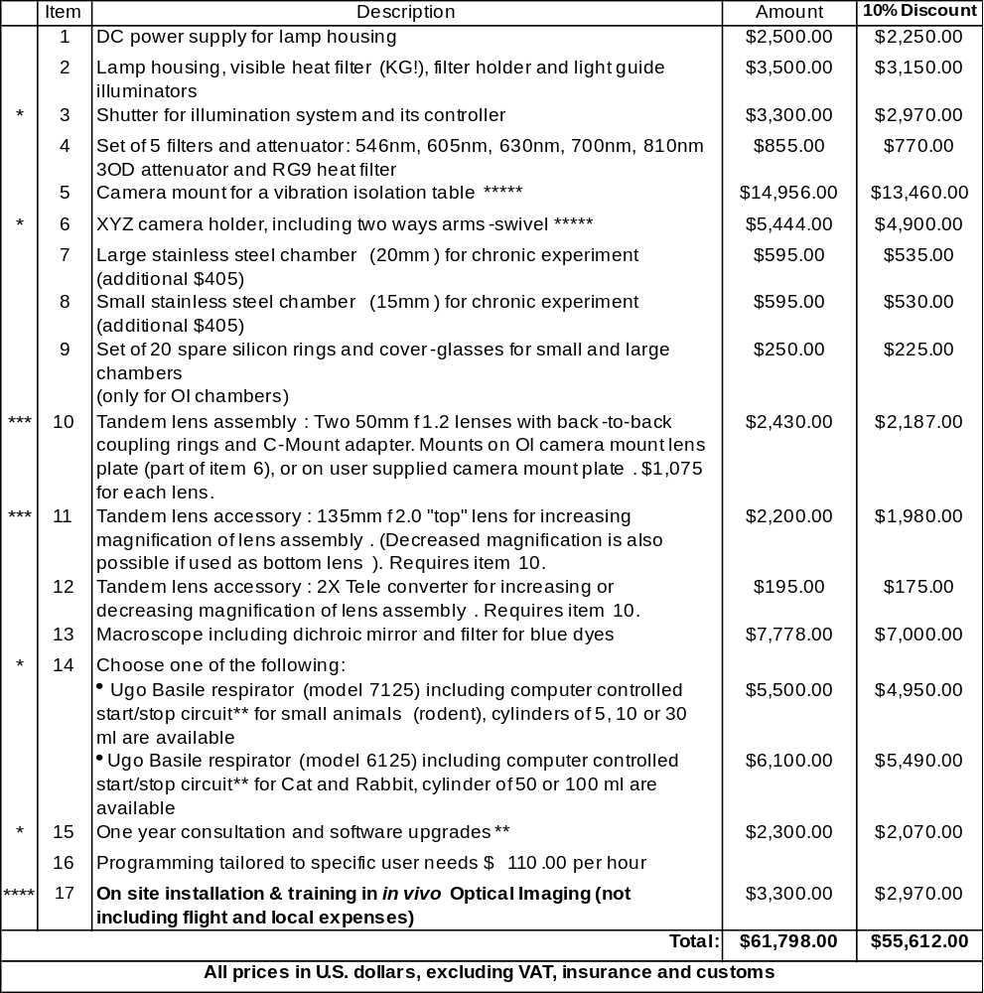

See detailed description at our new Web Site: http//www.opt-imaging.com

* Recommended by Optical Imaging. Detailed description available upon request or at our web site
** Please contact OI to discuss the extra support cost if you did not chose this option, yet it turned out that
*** The front-to-front lens ring adapters are provided only when option #6 (camera holder) and lenses are purchased
**** Purchase of on site installation is highly recommended, particularly for users who are new to the technique
of in - Vivo optical imaging. Contact Optical Imaging, Inc. to learn the availability of this service for your region.
***** All components of item 5 and 6 are installed and connected together.

Terms: 25% upon placing order, 75% remainder, NET two weeks after delivery
Shipment: Air freight and handling: Prepaid by OI- will be added to invoice.
The cost is buyer’s sole responsibility
Warranty: One year from date of shipment
Estimated shipping date: 60 days from receipt of purchase order.

- OI recommends purchasing the on-site installation and training package. Past experience Indicated that groups who do not have previous expiries with optical imaging save a lot of time in getting to the stage of performing high quality optical imaging expertise. The special service of OI should be coordinated in advance.

- OI does not include a monitor with either the Imaging Workstation or the Turn key Analysis workstation. Upon our experience we recommend that the user buy the monitors on his own to save shipping hazards and costs. At request we will quote and sell a large variety of LCD and computer monitors.

- OI recommends against installing tape drives, writeable CD drives, etc. on the Imaging Workstation. At the customer’s request, we will sell (options 7-8) a quote on additional backup devices for installation onto an Analysis Workstation or some other computer.

- The user needs to have a focusing monitor within easy view from the location of the camera. If your Imaging Workstation console monitor isn’t close to the camera location, the user can set-up a dual console monitor. Please contact us for further information if necessary.

- OI feels the systems work optimally as configured, but we are pleased to quote alternate CPU speeds, memory configurations, or disk configurations at the customer’s request.

